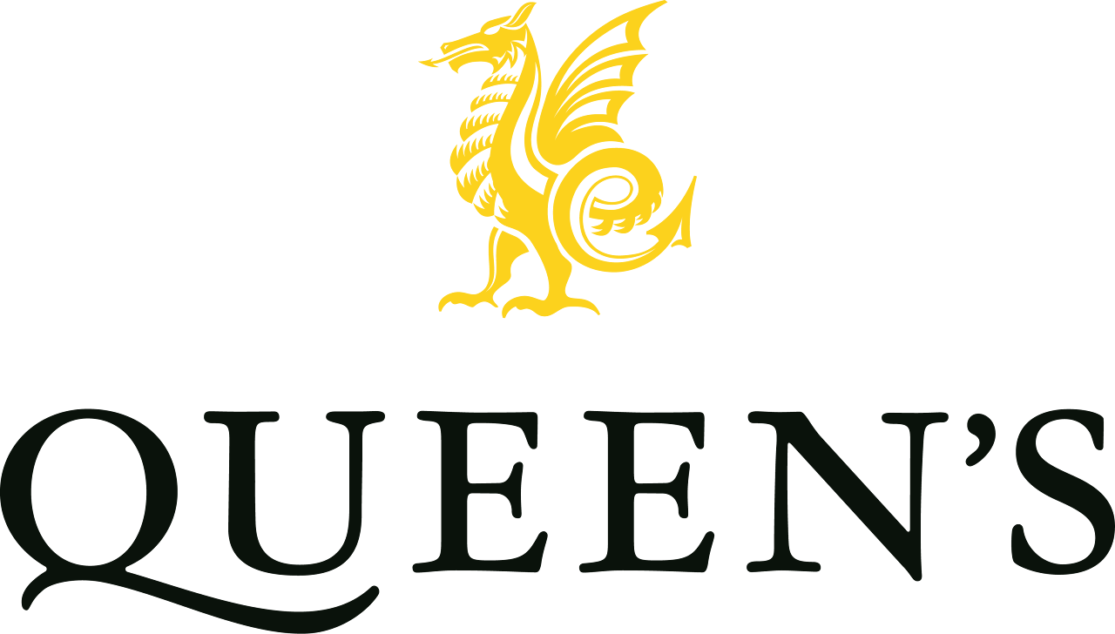



| **Job Title:** | Strength and Conditioning Coach |
| --- | --- |
| **Hours:** | Zero Hours |
| **Status:** | Permanent |

**Responsible to:** Director of Sport

**Job Purpose:**

The Strength and Conditioning (S&C) Coach will play a key role in supporting the physical development, performance, and wellbeing of pupils across the school. Working closely with the Sports Department, they will design and deliver age-appropriate training programmes that enhance athletic performance, reduce the risk of injury, and encourage lifelong healthy habits. The postholder will contribute to the school’s ambition to provide a sector-leading sports programme, while upholding its values of inclusivity, excellence, and personal development.

**Main Duties:**

* Design and implement progressive strength and conditioning programmes for pupils across a range of ages and sporting abilities, from beginners to high-performance athletes.
* Deliver engaging and safe coaching sessions in the school’s performance gym, on the field, and in other training environments.
* Support the physical preparation of school teams competing in regional and national competitions.
* Collaborate with sports coaches and medical staff to ensure integrated athlete development, rehabilitation, and injury-prevention strategies.
* Promote safe and effective use of the school’s fitness facilities by pupils and staff.
* Contribute to the wider PE and Sport curriculum by supporting lessons, co-curricular activities, and enrichment opportunities.
* Track and monitor pupil progress, providing feedback to individuals and contributing to reports for staff and parents as appropriate.
* Foster an environment that encourages effort, resilience, and enjoyment in physical activity.
* Undertake appropriate administrative tasks, including scheduling, record-keeping, and risk assessments.
* Maintain up-to-date knowledge of best practice in youth strength and conditioning, sports science, and safeguarding.

**Person Specification**

**Essential:**

* UKSCA accreditation (or working towards) or equivalent professional qualification.
* Proven experience of coaching young people in a strength and conditioning context.
* Strong knowledge of physical literacy, long-term athlete development, and injury prevention.
* Excellent communication, motivational, and organisational skills.
* A positive role model who demonstrates enthusiasm, professionalism, and commitment to pupil wellbeing.
* Understanding of safeguarding responsibilities and willingness to undertake training.

**Desirable:**

* Degree in Sports Science, Strength and Conditioning, or a related discipline.
* Experience working in an educational setting, particularly Independent Schools.
* Experience supporting athletes across multiple sports.
* First Aid qualification.

**Child Protection and Safeguarding**

Safeguarding and promoting the welfare of children is everyone’s responsibility. Everyone who comes into contact with children and their families has a role to play. In order to fulfil this responsibility effectively, all practitioners should make sure their approach is child-centred. This means that they should consider, at all times, what is in the best interests of the child (KCSiE 2025).

You must comply with the Queen's College Child Protection and Safeguarding Policy and Procedures and the requirement to report any concerns relating to the safety or welfare of children.

**Additional Duties:**

To undertake such additional duties as may be reasonably required commensurate with the level of responsibility within the College.

The post-holder will undertake assigned duties and responsibilities, ensuring that all actions are discharged within the regulatory and legislative requirements to which the College is subject.

**September 2025**

This job description is current at the above date. In consultation with the post holder it is liable to variation by the School to reflect actual, contemplated or proposed changes in or to the job.